PAN-ATLANTIC UNIVERSITY, SCHOOL OF SCIENCE AND TECHNOLOGY
DAT610: Ethics and Privacy, Continuous Assessment 1
Validation of a CTGAN Synthetic Transaction Dataset for a Fraud-Detection Model
Prepared by Yinka. 11 July 2026.

1. Introduction and Decision Context
A payments fraud-detection model requires training data, but real transaction records carry two problems that make direct use of production data inappropriate in a development environment: fraudulent cases are rare (about 1% of records), and the records expose personally identifiable information whose use outside production is restricted by internal policy and by the Nigeria Data Protection Act (2023). Generating synthetic transactions with a Conditional Tabular GAN (CTGAN) is a legitimate response to both problems (Xu et al., 2019). The moment that choice is made, however, three professional obligations become active: the synthesis must be documented, its distributional alignment with real data must be validated with evidence, and its use must be disclosed before any model trained on it reaches production.
This report answers a single question: should the synthetic dataset generated for this exercise be approved for release into production? It documents the generation workflow, presents evidence against every metric of the five-level validation framework, and closes with a recommendation and the completed Synthetic Data Card. The recommendation, stated up front so that the evidence can be read against it, is that the synthetic dataset must not be approved in its current form.

2. Workflow

2.1 The real dataset
The real dataset contains 2,000 transaction records with eight features: transaction_amount (continuous, Naira), customer_age (discrete, 18 to 75), account_balance (continuous, balance before the transaction), num_transactions_30d (discrete), transaction_hour (discrete, 0 to 23), distance_from_home_km (continuous), merchant_category (categorical with five levels), and the binary target is_fraud. Exactly 20 records (1.00%) are fraudulent, matching the class imbalance the production system faces. Fraudulent records carry a recognisable joint signature: larger amounts, hours concentrated late at night, and long distances from the registered home address. Preserving that joint signature, not merely the individual column shapes, is what the synthesis must achieve for a fraud model to learn anything useful.

2.2 Generating the synthetic dataset with CTGAN
Synthesis used the CTGAN implementation in the Synthetic Data Vault library (Patki et al., 2016; Xu et al., 2019). The single-table metadata was first auto-detected and then explicitly corrected before training, because a misclassified column type corrupts generation silently: is_fraud and merchant_category were set to categorical, and the three count-like columns were fixed to integer representation. Auto-detection alone would have let the model treat the binary target as a continuous number to regress, which would have been discovered only after wasted training runs.
The synthesiser was trained for 300 epochs, the standard configuration for this exercise, with a fixed random seed for reproducibility. One deliberate deviation from defaults was the batch size, raised from 500 to the full table size of 2,000. With only four batches per epoch at the default, the adversarial game receives few and noisy updates; full-batch training gives the discriminator a stable view of the entire table at every step, which is appropriate for a table this small. After training, 2,000 synthetic rows were sampled so the two datasets are directly comparable, and the generation facts were recorded immediately in the Synthetic Data Card with validation status PENDING.

2.3 Validation design
Validation followed the five-level framework: summary statistics, visual distributions, statistical tests, machine-learning utility, and privacy. For the utility test, 20% of the real data (400 records, 4 fraud cases) was held out with stratification before any training. The Train-Real-Test-Real (TRTR) baseline and the Train-Synthetic-Test-Real (TSTR) model are random forests with identical configuration (Pedregosa et al., 2011), both evaluated on that same held-out real test set. Pass criteria were fixed in advance: means within 10% of real, visual alignment of shapes and correlations, Kolmogorov-Smirnov p above 0.05 for every continuous column, Chi-squared p above 0.05 for every categorical column, normalised Wasserstein distance below 0.15 per feature, an absolute TSTR versus TRTR AUC gap below 0.05, and a Distance to Nearest Neighbour Ratio (DNNR) above 1.5. Every number reported below is read directly from the validation script output (validation_results.json).

3. Results

3.1 Level 1: Summary statistics
Table 1 compares means feature by feature. Two of six numeric features sit inside the 10% screening tolerance: account_balance (8.0%) and transaction_hour (9.6%). The remaining four breach it, and two do so catastrophically: transaction_amount is overstated by 88.4% and distance_from_home_km by 971.8%, both far beyond the 20% level at which the framework says do not proceed. The class balance fails hardest of all: the real fraud rate is 1.00% while the synthetic rate is 14.55%, a factor of 14.5 inflation. A model trained on this synthetic set would learn a world in which fraud is a routine event rather than a rare one.
Feature | Real mean | Synthetic mean | Difference | Within 10%?
transaction_amount | 27,398.10 | 51,610.82 | 88.4% | No
account_balance | 295,523.54 | 271,886.71 | 8.0% | Yes
distance_from_home_km | 9.04 | 96.89 | 971.8% | No
customer_age | 38.67 | 44.82 | 15.9% | No
num_transactions_30d | 12.32 | 13.65 | 10.8% | No
transaction_hour | 14.71 | 13.29 | 9.6% | Yes
is_fraud rate | 0.0100 | 0.1455 | 1,355% | No
Table 1. Level 1 screening: side-by-side means and the fraud rate.

3.2 Level 2: Visual distributions
Figure 1 overlays kernel density estimates for the six numeric features. The plots show that the failures found at Level 1 are failures of shape, not just of location. For transaction_amount the synthetic curve is flatter with a long inflated right tail, so mass has moved from ordinary purchases into large transactions. distance_from_home_km is the most damaged feature: the real data is a sharp spike near zero (most customers transact close to home) while the synthetic density spreads across hundreds of kilometres. transaction_hour shows a spurious early-morning mode near 01:00 that barely exists in the real data; this is the 14.55% synthetic fraud share dragging night-time fraud hours into prominence. customer_age drifts old, and num_transactions_30d grows a small artificial mode around 44 transactions, an echo of the high-velocity fraud pattern that the generator has over-represented.
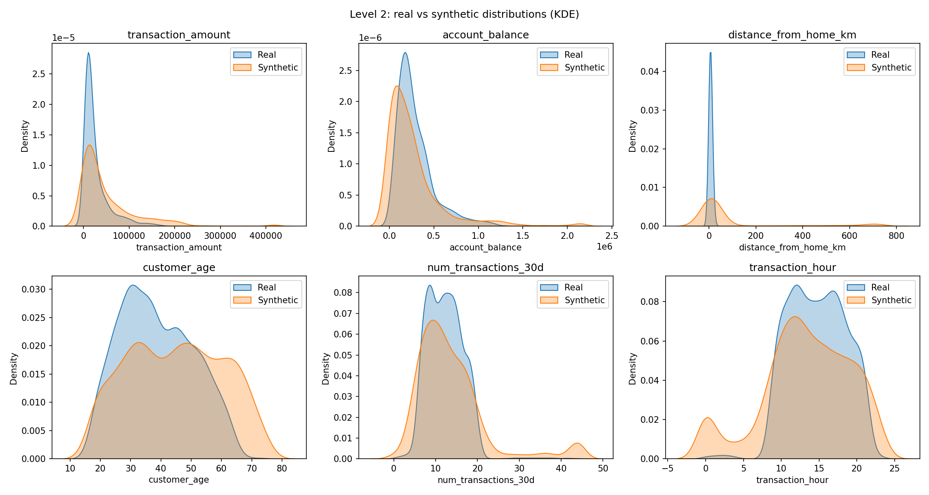
Figure 1. Kernel density estimates, real versus synthetic, for the six numeric features.
Figure 2 compares categorical proportions. The merchant mix is visibly reshaped: grocery falls from 0.35 to 0.22 while electronics and travel, the categories most associated with fraud in the real data, are inflated to roughly double their real share. The right panel makes the is_fraud mismatch visible without any statistics. Because a fraud model's operating threshold is set against expected prevalence, this panel alone is disqualifying.
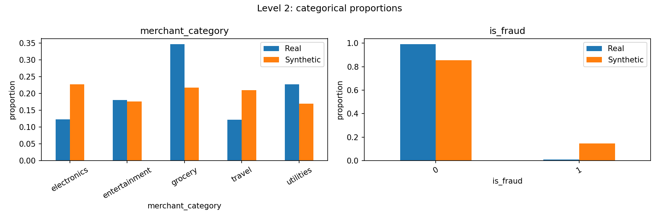
Figure 2. Categorical proportions for merchant_category and is_fraud.
Figure 3 is the decisive diagnostic. The real correlation heatmap has strong structure: transaction_amount and account_balance correlate at 0.97, distance_from_home_km and is_fraud at 0.84, and customer_age is negatively related to transaction_hour at -0.74. The synthetic heatmap is almost uniformly grey: nearly every off-diagonal value has collapsed towards zero, with a maximum absolute gap of 0.971. The three worst losses are amount versus balance (0.973 to 0.001), distance versus fraud (0.842 to 0.049), and balance versus age (0.817 to 0.029). The generator has approximated the columns while destroying the relationships between them. Since distance-from-home is the strongest single fraud signature, its disappearance means the joint pattern a fraud model must learn is simply not present in the synthetic table. This is the exact failure mode the framework warns about: marginals can look plausible while the correlation structure, and with it the fraud signal, is gone.
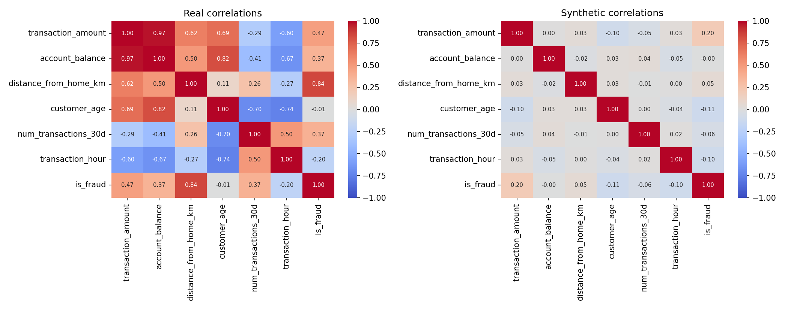
Figure 3. Correlation heatmaps for real (left) and synthetic (right) data. Colour is used here because a diverging scale is required to distinguish positive from negative correlation.

3.3 Level 3: Statistical tests
Table 2 reports the three test families. The Kolmogorov-Smirnov test rejects distributional equality for all three continuous columns; the largest statistic belongs to distance_from_home_km (0.414), meaning the real and synthetic cumulative distributions are separated by 41 percentage points at their widest gap. The Chi-squared test rejects both categorical columns; the is_fraud statistic of 3,709 on one degree of freedom is the single loudest number in the audit. The normalised Wasserstein distances translate these rejections into magnitudes: every feature exceeds the 0.15 threshold, from 0.36 for account_balance to 2.46 for distance_from_home_km, which is sixteen times the acceptable drift. The two test types are complementary: KS gives the binary verdict, Wasserstein shows how much reshaping work would be needed, and here both agree everywhere.
Test | Feature | Statistic | p-value / score | Pass?
KS (continuous) | transaction_amount | 0.1935 | p < .001 | No
KS (continuous) | account_balance | 0.2200 | p < .001 | No
KS (continuous) | distance_from_home_km | 0.4140 | p < .001 | No
Chi-squared (df 4) | merchant_category | 423.94 | p < .001 | No
Chi-squared (df 1) | is_fraud | 3,709.14 | p < .001 | No
Wasserstein (norm.) | transaction_amount | 0.7406 | > 0.15, poor | No
Wasserstein (norm.) | account_balance | 0.3591 | > 0.15, poor | No
Wasserstein (norm.) | distance_from_home_km | 2.4640 | > 0.15, poor | No
Wasserstein (norm.) | customer_age | 0.5254 | > 0.15, poor | No
Wasserstein (norm.) | num_transactions_30d | 0.5165 | > 0.15, poor | No
Wasserstein (norm.) | transaction_hour | 0.4824 | > 0.15, poor | No
Table 2. Level 3 statistical tests: Kolmogorov-Smirnov, Chi-squared and normalised Wasserstein distance.

3.4 Level 4: Machine-learning utility (TSTR versus TRTR)
On the shared 400-record real test set, the TRTR baseline achieves an AUC of 1.0000 and the TSTR model also achieves 1.0000, an absolute gap of 0.0000 that formally satisfies the strictest band of the criterion. Average precision is likewise 1.0 for both. This result must be read with care rather than celebrated. First, the test set contains only 4 fraud cases, so ranking metrics have very little statistical power and saturate easily. Second, the real fraud cases are extreme on several features at once, so even a distorted training signal that preserves the direction (fraud is larger, farther, later) ranks them correctly. What the test cannot certify is the operating behaviour of a deployed model: a classifier trained at 14.55% prevalence has a decision threshold calibrated to a world with fifteen times more fraud, and in production it would over-flag legitimate customers at a rate the alert-handling team could not absorb. Level 4 therefore passes in form while the deployment risk it is meant to detect remains, which is precisely why the framework requires all five levels rather than the utility test alone.

3.5 Level 5: Privacy (DNNR)
The median distance from each synthetic record to its nearest real record is 3.174 in standardised feature space, against a median real-to-real nearest-neighbour distance of 0.012, giving DNNR = 274.7. This is far above the 1.5 threshold: no synthetic record shadows a real one, and memorisation can be ruled out. One honest caveat belongs in the record: the margin is inflated by the same infidelity documented at Levels 1 to 3, because synthetic points that sit far from the real data manifold are, by construction, far from real individuals. Privacy is achieved here partly as a by-product of poor fidelity rather than as evidence of a well-behaved generator.

4. Discussion
The evidence forms a coherent pattern: the privacy check passes decisively, the utility check passes only in a formal and low-powered sense, and every fidelity check from Level 1 to Level 3 fails, several of them by an order of magnitude. Three causes explain the outcome. First, 2,000 records is a small training corpus for an adversarial generator, and only 20 of them are fraudulent; a GAN cannot learn the joint distribution of a minority class from 20 examples. Second, CTGAN's training procedure deliberately over-samples rare categories through its conditional vectors so the generator sees minority classes often; without a corrective conditional sampling step at generation time, that training-time re-balancing leaks into the output, which is exactly the 1.00% to 14.55% prevalence inflation observed. Third, the heavy right tails of the Naira amount and distance features stress the mode-specific normalisation on a small sample, producing the tail inflation visible in Figure 1.
The interplay between levels is the professional lesson. Had validation consisted of the utility test alone, the dataset would have been approved on a perfect AUC gap and deployed; the resulting model would have failed silently in production through mis-calibrated alert volumes, with no traceable cause in any single component. The statistical levels catch what the utility test cannot see, and the visual level explains why: the correlation heatmap shows the fraud signature being erased even while column shapes remain superficially plausible. A data scientist who deploys on synthetic data without this evidence is making a claim about the world that they cannot substantiate, and the professional codes are explicit that avoiding foreseeable harm and honesty about limitations are obligations, not courtesies (Association for Computing Machinery, 2018). The regulatory context points the same way: data governance and accuracy duties for high-risk automated decision systems arise under the EU Artificial Intelligence Act (European Union, 2024), and the accuracy and safeguard provisions of the Nigeria Data Protection Act (2023) apply to the processing that this pipeline performs. Documenting a failed validation and refusing deployment is the professionally defensible outcome; the standard does not require a perfect generator, it requires evidence.

5. Recommendation
Do not approve this synthetic dataset for release into production, and do not use it to augment real training data in its current form. The disqualifying evidence is the 14.55% synthetic fraud prevalence against a real 1.00%, the rejection of every continuous column by the Kolmogorov-Smirnov test and of every categorical column by the Chi-squared test, normalised Wasserstein drift above threshold on all six numeric features, and the collapse of the correlation structure that carries the fraud signal (0.842 to 0.049 for distance versus fraud).
Remediation should proceed in order of expected impact. Generate with an explicit conditional constraint on is_fraud so the output prevalence matches the real 1.00%, or synthesise the two classes separately and recombine at the true rate. Enlarge the real fraud sample if operationally possible, since 20 minority examples is below any reasonable floor for GAN training. Re-tune training with the loss curves inspected rather than assumed, comparing epoch counts and batch sizes. Benchmark CTGAN against TVAE and a Gaussian copula on this table, since copula models are often stronger on small tables and are fully interpretable. Finally, re-run the entire five-level validation on any regenerated dataset, and only complete the disclosure and sign-off sections of the Synthetic Data Card when Levels 1 to 3 pass, the TSTR gap stays within 0.05, and DNNR remains above 1.5.

6. Synthetic Data Card
Section | Field | Value
Generation | Date generated | 11 July 2026
Generation | Generator model | CTGAN via the SDV library, 300 epochs, batch size 2,000, fixed seed
Generation | Training data source | transaction_dataset.csv, 2,000 real fraud-detection records
Generation | Records (real / synthetic) | 2,000 / 2,000
Generation | Purpose | Fraud-detection model development without PII exposure
Generation | Data sensitivity | Financial; no raw PII in output
Generation | Generated by | Yinka, Data Scientist
Validation | Level 1 means within 10% | 2 of 6 features; fraud rate 0.0100 vs 0.1455: FAIL
Validation | Level 2 visual alignment | Correlation structure destroyed (max gap 0.971): FAIL
Validation | Level 3a KS (continuous) | 0 of 3 columns aligned, all p < .001: FAIL
Validation | Level 3b Chi-squared (categorical) | 0 of 2 columns aligned, all p < .001: FAIL
Validation | Level 3c Wasserstein (normalised) | 0 of 6 features below 0.15 (0.36 to 2.46): FAIL
Validation | Level 4 TSTR vs TRTR AUC gap | 0.0000 (1.0000 vs 1.0000): PASS, low statistical power noted
Validation | Level 5 privacy DNNR | 274.7 (threshold 1.5): PASS
Validation | Validated by | Yinka, 11 July 2026
Validation | Validation status | FAILED. Not approved for production or augmentation
Disclosure | Stakeholders notified | Course instructor (acting data lead), before any deployment decision
Disclosure | Documentation | This report; validation_results.json; metadata.json; scripts 01 and 02
Disclosure | Approval sign-off | Withheld pending remediation and full re-validation
Table 3. Synthetic Data Card covering generation, validation evidence and disclosure.

References
Association for Computing Machinery. (2018). ACM code of ethics and professional conduct. https://www.acm.org/code-of-ethics
European Union. (2024). Regulation (EU) 2024/1689 of the European Parliament and of the Council (Artificial Intelligence Act). Official Journal of the European Union.
Nigeria Data Protection Act, 2023 (Nigeria).
Patki, N., Wedge, R., & Veeramachaneni, K. (2016). The Synthetic Data Vault. 2016 IEEE International Conference on Data Science and Advanced Analytics (DSAA), 399-410. https://doi.org/10.1109/DSAA.2016.49
Pedregosa, F., Varoquaux, G., Gramfort, A., Michel, V., Thirion, B., Grisel, O., Blondel, M., Prettenhofer, P., Weiss, R., Dubourg, V., Vanderplas, J., Passos, A., Cournapeau, D., Brucher, M., Perrot, M., & Duchesnay, E. (2011). Scikit-learn: Machine learning in Python. Journal of Machine Learning Research, 12, 2825-2830.
Xu, L., Skoularidou, M., Cuesta-Infante, A., & Veeramachaneni, K. (2019). Modeling tabular data using conditional GAN. Advances in Neural Information Processing Systems, 32.

